Project Title: City View Scenario.

Introduction:

This project is all about a scenario which is animated with the help of Opengl library to make a real-life situation of city. This kind of project is mainly called Glut project which is implemented by the programming language named C++ along with many different opengl libraries like glu.glut etc. The interesting part of this project is, it will give a real teste of city life and for this some moving objects like the city observing like city observing clouds, cars and the citizens.

Problem Statement:

In our project we can see different scenarios. Frist of all, we can see a city view in the screen. We are able to see the night and day mode beside early morning mode. We are able to see the moving object like car, ship, sun and also see the fixed object like highway, lamp post and hills.

Objects of the project:

The goal of this project is to well understand how open Gl projects work and how the basics of graphics design are started.

Methodology:

We have done our project a lot of function or methodology. Many function are include like rectangle, triangle, quads, push pop matrix function, polygon, color, time function etc.

Significant of the project:

Day-night view is the most significant in our project. Another beautiful view are sun, moon and rain. Color combination are pretty good. Step by step change our scenario view process. So, we tried our best to make the beautiful view.

Conclusion:

The project is well suited for designing 2D and 3D objects, as well as for carrying out basic graphics functionalities like drawing a simple line, creating a cube, circle, square, erasing and filling them however, implemented on large scale with sufficient resources, it has the potential to become a standard stand-alone GUI based application for Window Operating System. Out of the many features available, the project demonstrates some popular and commonly used features of OpenGL. Such as Rendering , Transformation Rotation, Lighting , Scaling etc.

References:

1. <https://youtu.be/EkoNDPkzxZE>
2. <https://youtu.be/mLKLx1RLV8>

Screenshot of the system:

1. Early morning View:

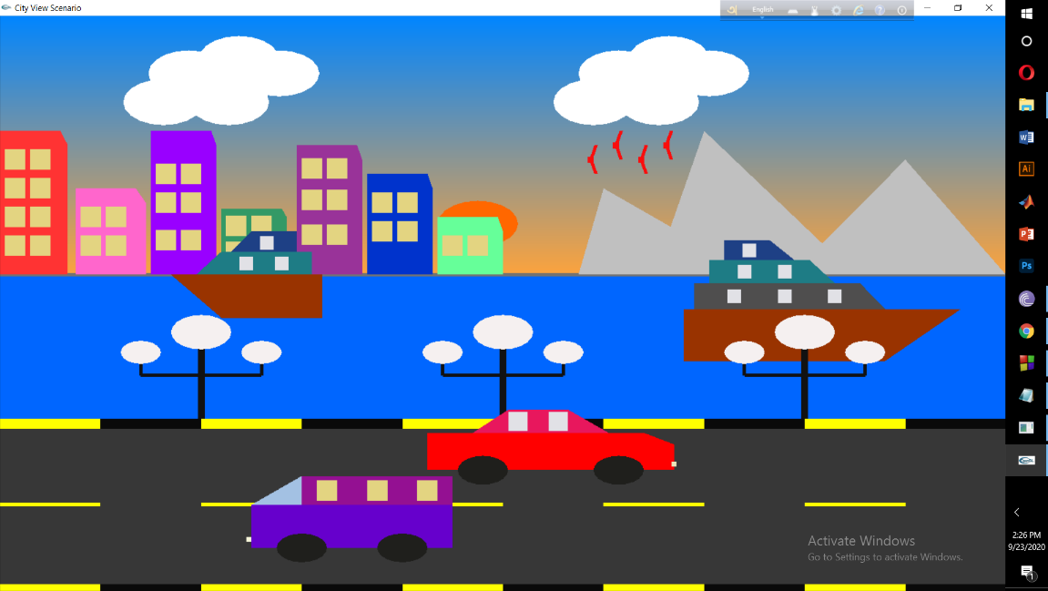

1. Morning View:

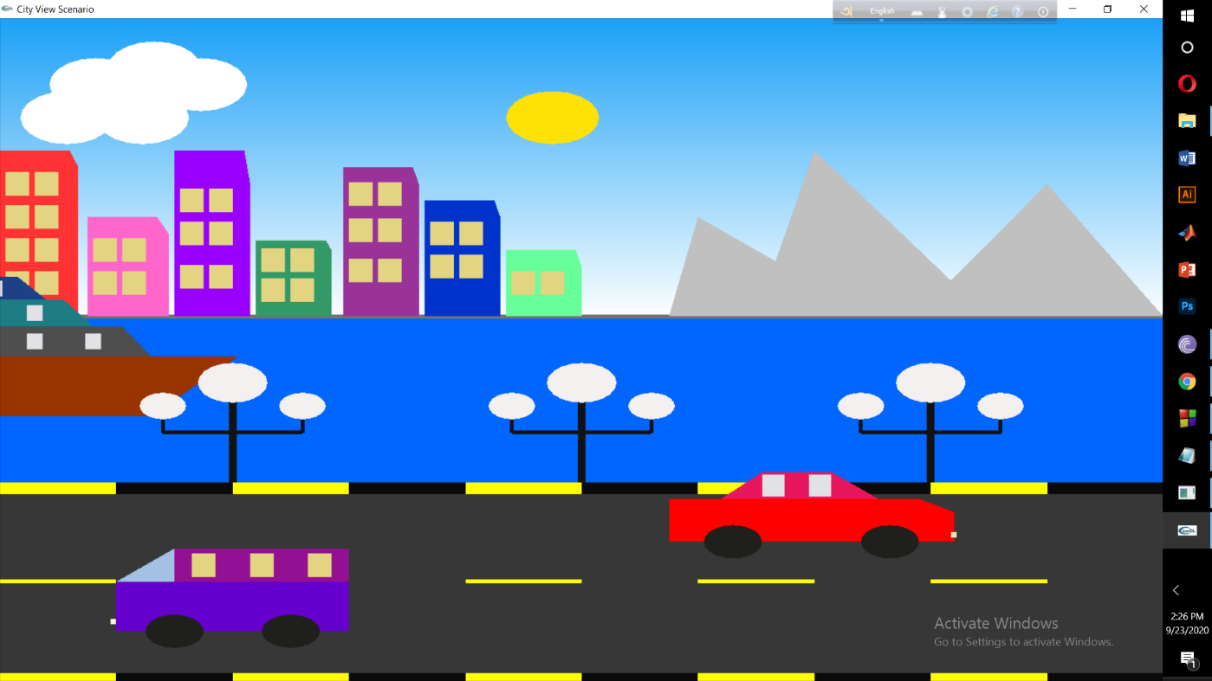

1. Night View:

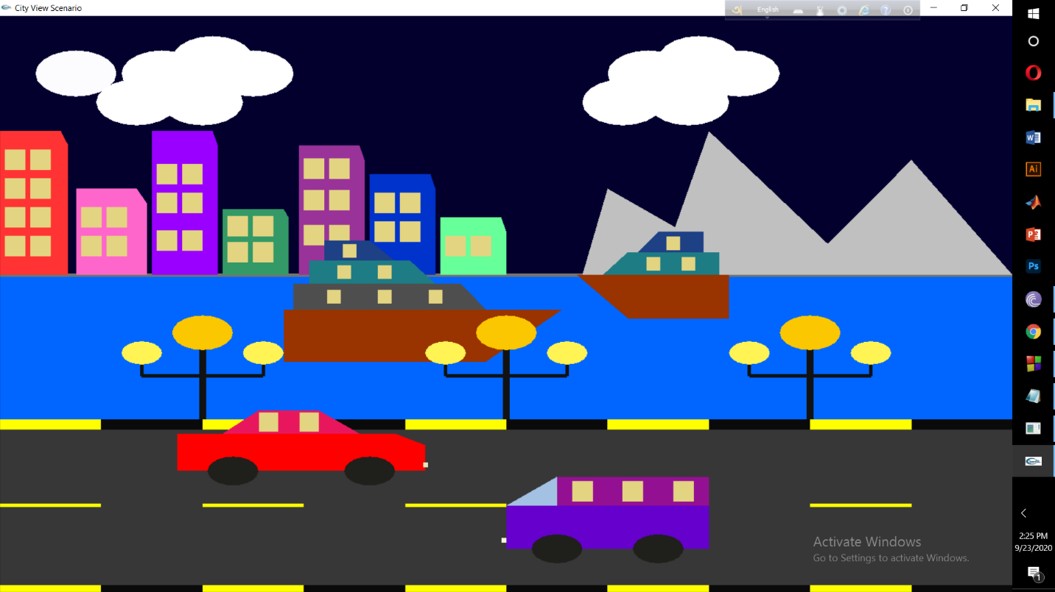

1. Rain View:

